On the Performance of Fractal Compression with Clustering
Christopher J. Wein and Ian F. Blake
IEEE Transactions on Image Processing, Vol. 5, No. 3, pp. 522-526, Mar. 1996
Abstract
This paper investigates a technique to reduce the computational complexity of fractal image compression on gray-scale image.
- Introduction
Fractal compression is a heavily unbalanced technique; the computational requirements of the compression algorithm are orders of magnitude greater than those of the decompressor.
- Fractal Image Compression
- Conventional Speed-up Techniques
A technique to reduce the complexity of the search is to subsample the set of domain blocks to be searched. Two other clustering techniques that have been widely used are quadrant brightness and quadrant variance classification.
- Quadrant brightness classification is based on the premise that a domain and range block that have similar areas of light and dark.
- Quadrant variance classification is based on the similar premise that a domain and range block that have similar areas of high variance (edge) and low variance (shade).
- Fractal Compression Using Clustering
For a given range block, the search for a matching domain block is in two levels. At the first level, the best cluster is located. At the second level, the best domain block within the cluster is located.

- The Fast Pairwise Nearest Neighbor Clustering Algorithm
The PNN algorithm starts by assigning one cluster to each of the domain blocks and then successively merges clusters two at a time until the desired number of clusters is reached. Total number of clusters is decreased by one for each merge.
The fast PNN algorithm initializes by first partitioning the domain blocks using a k-d tree and then assign one cluster to each of the domain blocks.
It merges the clusters C_{i} and C_{j} that minimize
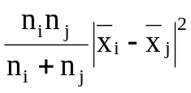
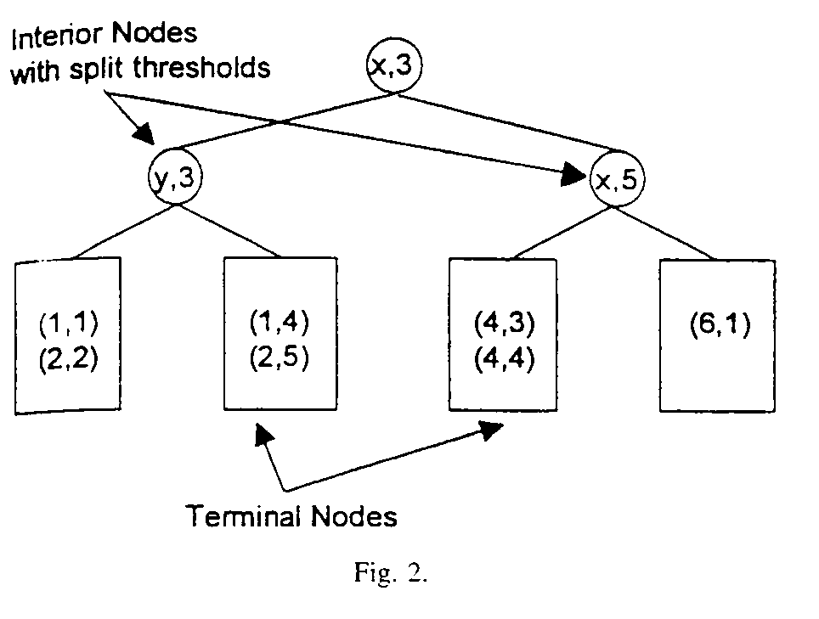
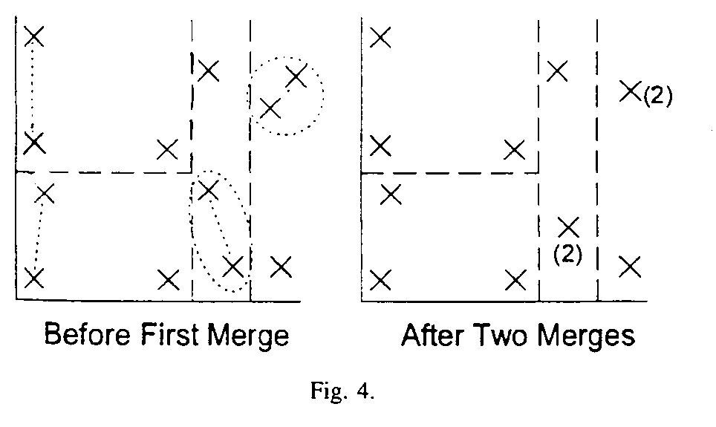
- Experimental Results
This section presents test results that compare the performance of quadrant variance classification and clustering as described. The objective of the tests was to measure the speedup of the compression process versus image quality for each of the two algorithm.
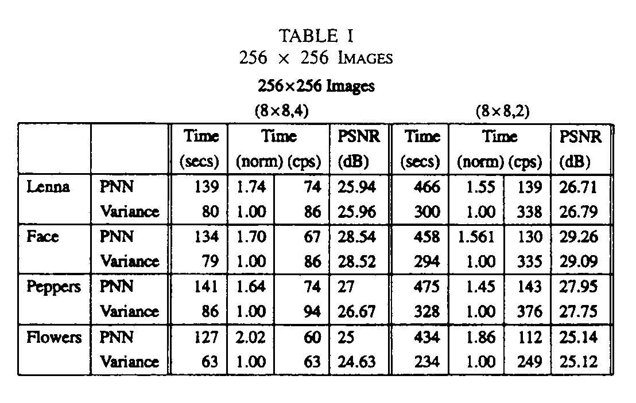
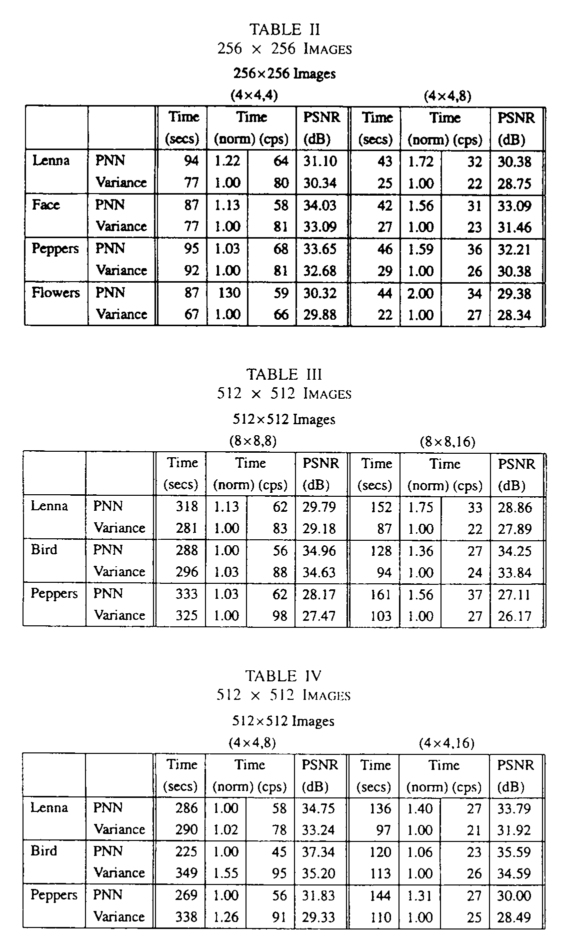
Created by : Chia-Hao Yang
Date : May 6, 1998

